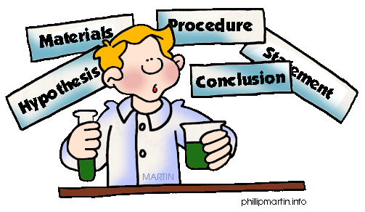
Labels to Remember
for your Science Project Board…

TITLE- Your project title should catch attention and create interest. Pick a “catchy” title. Ask yourself if it will make the judges and students stop to see what your project is about. Titles usually look best when done in clear, bold type, large enough that they can be read from a distance. Font size for a title is usually 50-100.
OBJECTIVE, PURPOSE, OR QUESTION- Find a topic that interests you and decide what you want to learn from this project. You will be conducting an experiment to find the answer to what you want to learn on your topic.
Research- gather information about the question you want to learn about or explore.
HYPOTHESIS- After researching your topic and finding out everything you can, you will now make an educated “guess” as to what will happen in your experiment.
PROCEDURE OR EXPERIMENT- This is the part where you perform your experiment to find out the answer to your Objective, Purpose, or Question.
INDEPENDENT VARIABLE- This is the element of your experiment that you will change to answer your hypothesis. For the example project in class, the independent variables were the different solutions to clean the pennies.
DEPENDENT VARIABLE- This is what happens in response to changing the independent variable. For the same penny sample project, the pennies were the dependent variable.
CONTROL- The control is the element of the experiment where the dependent variable is left unchanged. A penny that was not put in any solution is the control.
RESULTS- This is where you post all the before and after pictures of your experiment. This is also where you display your graphs or charts showing the information of your experiment.
MATERIALS- List all items used and be sure to state how much (in metrics) was used. Any measurement of any kind needs to be in metrics (millimeters, meters, centimeters, liters, etc).
CONCLUSION OR DISCOVERY- This includes: 1. The results of the experiment- Was your hypothesis correct or incorrect? 2. Why? 3. What did you learn? 4. What would you do different if you do it over again? (What would you change? Would you use a different independent variable…)

**Also, remember to bring your logbook/journal/data book with you.

